**Objective:**

To propose the development of a mobile application platform outside the current group-native platform (iOS/Android), leveraging Flutter and modern tools to accelerate delivery, enhance flexibility, and maintain alignment with group-wide standards.

**1. Speed to Market**

Building outside the native group platform allows the team to rapidly prototype, develop, and deploy mobile applications. Flutter’s cross-platform capability enables simultaneous development for iOS and Android from a single codebase, reducing time-to-market and enabling faster response to customer needs and business opportunities.

**2. Talent Utilisation and Flexibility**

This approach allows us to leverage existing internal skills (including Flutter and cross-platform expertise) and reduce the dependency with the OML Mobile Application Platform team and the OMAR data platform teams. Augmenting internal capacity with external partners is easy to manage as getting access to Flutter developers is much easier compared to getting Native Android and iOS developers. Native developers for iOS/Android are scarce to find in Zimbabwe market and the cost of getting them on board is higher.

**3. SSO and Omni-Channel Experience Considerations:**

We recognise the importance of seamless customer journeys and unified identity across all digital touchpoints which is one of the key benefits that building on the OML platform was going to assist with through PING integration. To ensure that we remain aligned to that strategy we are proposing adopting AWS Cognito as the unified authentication layer for both Secure Web and Group App channel and extend it to the group digital channels in an iterative approach. We have done a research on AWS Cognito and its currently supported in our current AWS environment and this solution provides scalability, security, and extensibility, positioning us to deliver an omnichannel experience that aligns with group strategy.

**4. AWS Cognito Costs**

Offers a pay-as-you-go model, typically free for the first 50,000 monthly active users (MAUs), with low incremental costs thereafter. It eliminates the need for building and maintaining a custom identity platform, providing cost-effective scalability. [See table below for pricing]

**SNS**

AWS charges $0.25091 per SMS to Zimbabwe, resulting in a total cost of $125,455 for user registration.  
For password resets, assuming 10% of users change their password, the cost is $12,545.  
Total estimated cost: $138,000.

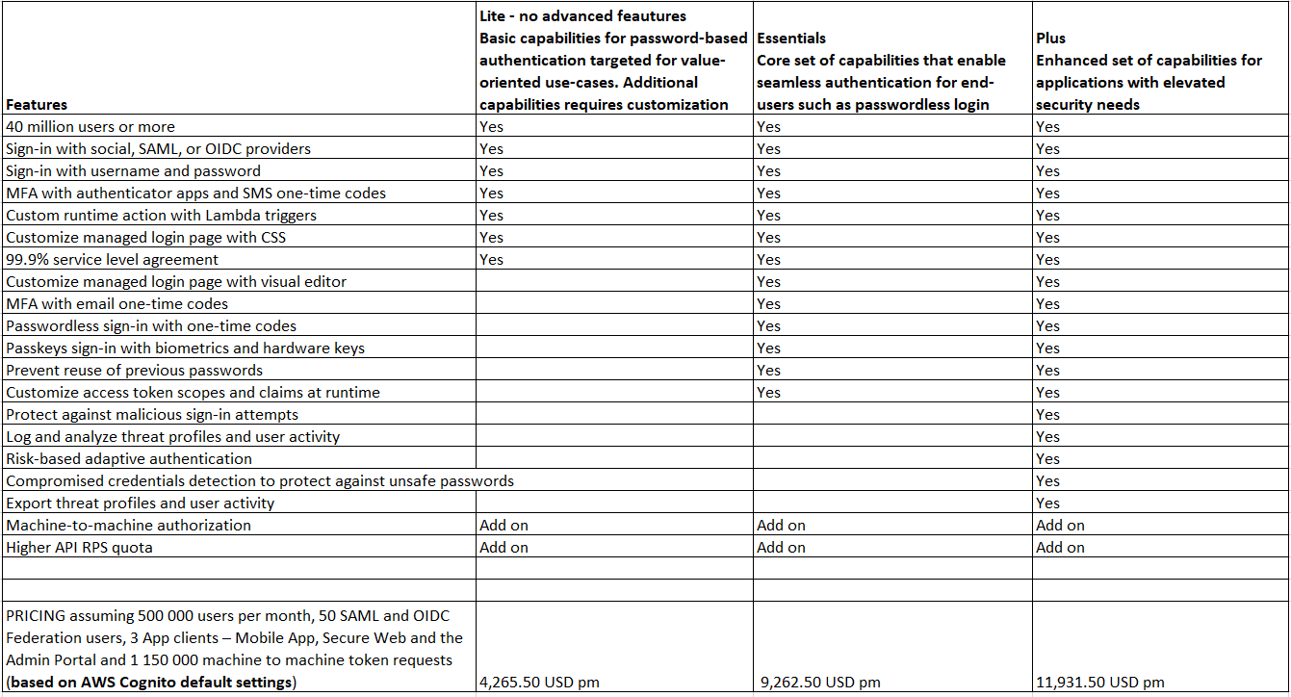

**Ways to optimize costs**

To reduce costs and improve efficiency, we can consider the following strategies:

* **Extend Token Expiry Times:** Increase the lifespan of access tokens from the default to minimize the frequency of token generation.
* **Use Refresh Tokens Effectively:** Leverage refresh tokens to maintain sessions without requiring frequent re-authentication.
* **Implement Token Caching:** Store tokens securely on the client side to reduce repeated requests.
* **Use User Sessions Efficiently:** Manage user sessions to avoid unnecessary token renewals.
* **Analyze and Monitor Token Requests:** Regularly assess token usage patterns to identify optimization opportunities.

Example Scenario:  
By extending the access token lifespan to 24 hours and efficiently utilizing refresh tokens, the login frequency could decrease from twice per month to once per month. This change would reduce the numberof login requests from 1,000,000 to 500,000, effectively cutting the M2M token cost by half.

**END**